**M.I.T. LAB Assignment – 08**

**U19CS012**

**1.** Write a program to convert a given number of ***binary*** data bytes into their ***BCD*** equivalents, and store them as *unpacked BCDs* in the output buffer.

The number of data bytes is specified in register D in the main program.

The converted numbers should be stored in groups of three consecutive memory locations. If the number is not large enough to occupy all three locations, Zeros should be loaded in those locations.

Notepad Code:

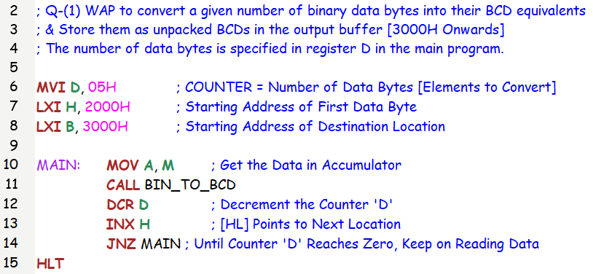

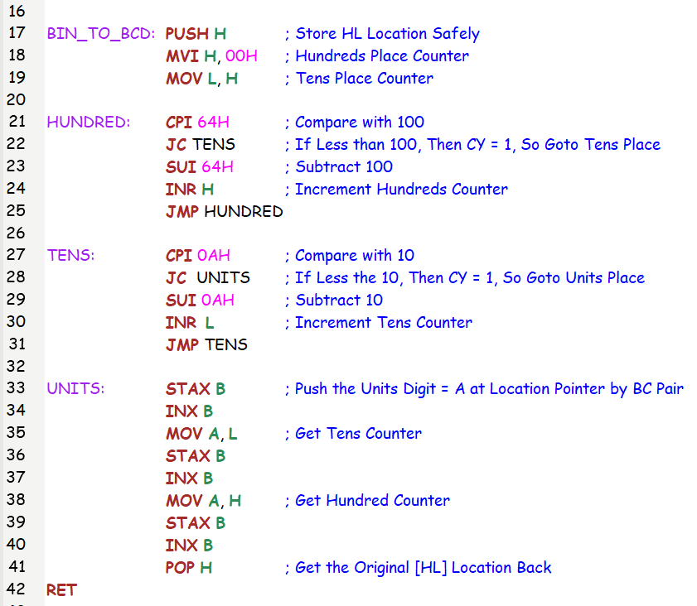

Input: Counter D = 5 Numbers, {124,47,6,96,189}

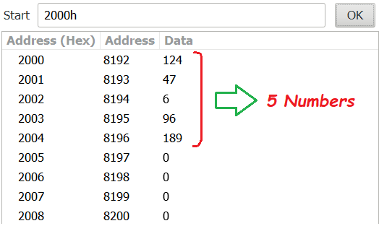

Output:

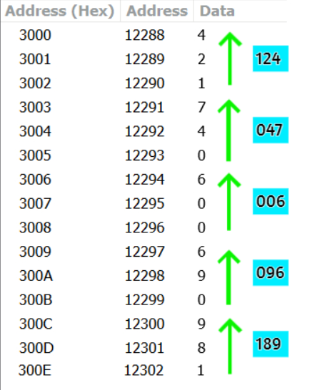

**2.** A set of ten BCD readings is stored in the Input Buffer. Convert the numbers into binary and add the numbers. Store the sum in the Output Buffer, the sum can be larger than FFH.

Notepad Code:

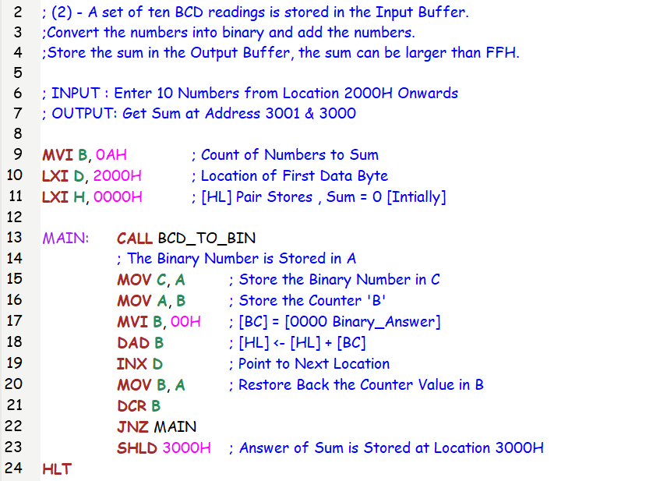

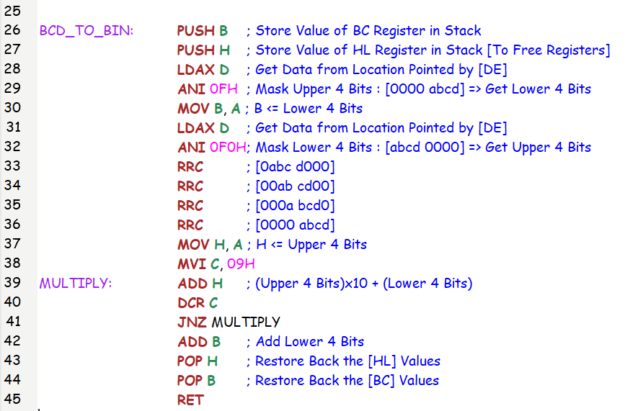

Input:

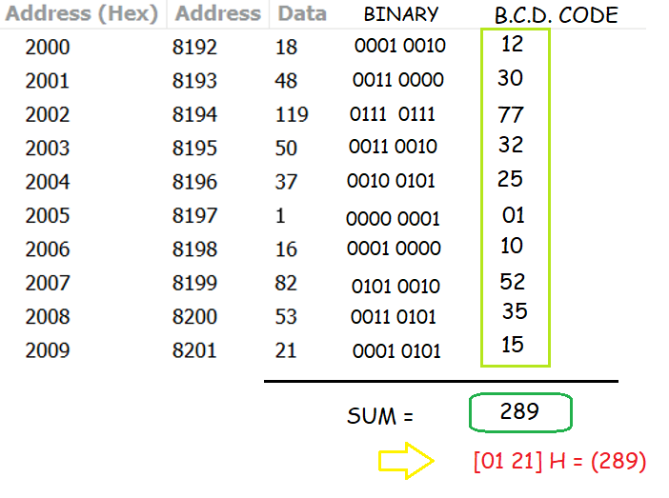

Output:

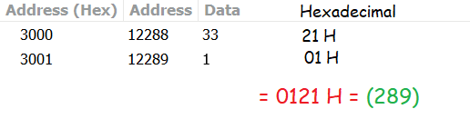

**3.** A set of ASCII Hex digits is stored in the Input Buffer memory. Write a program to convert these numbers into binary.

Add these numbers in binary, and store the result in the Output-Buffer memory.

Notepad Code:

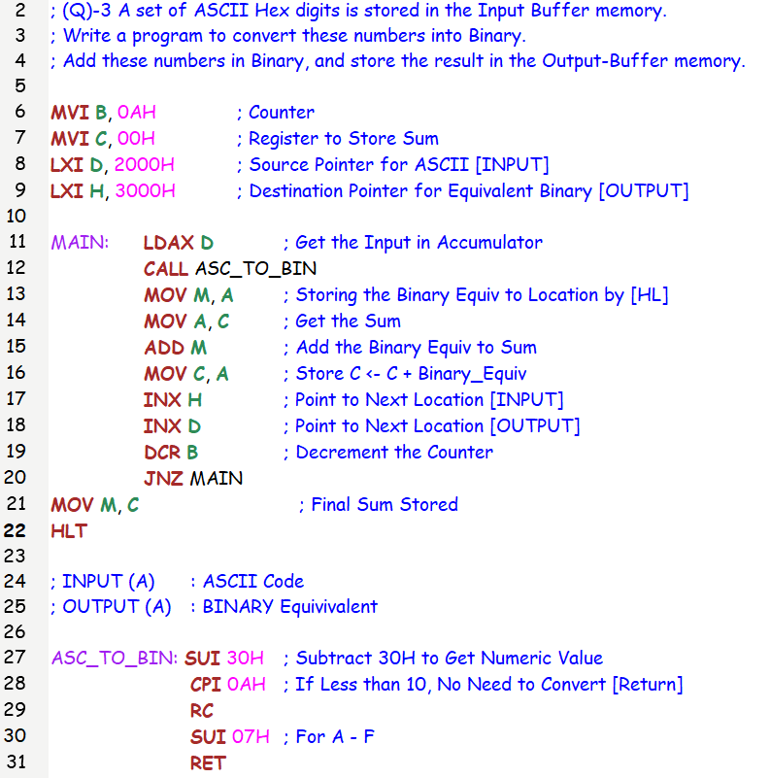

Input:

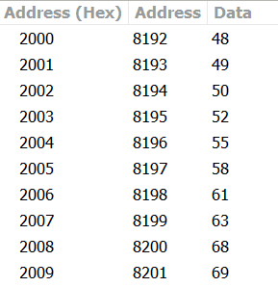

Output:

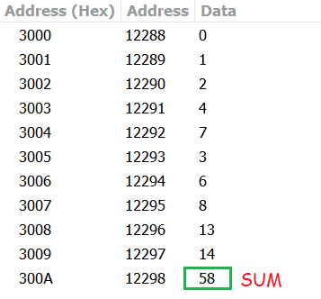

SUBMITTED BY:

BHAGYA VINOD RANA

[***U19CS012***]